ANTI-SOCIAL BEHAVIOUR, CRIME AND POLICING ACT 2014 (the “Act”)
The Mansfield District Council Public Spaces Protection Order 2022
(the “Order”)
Mansfield District Council (“the Authority”), being satisfied that:

- Activities as described in articles 1-10 below which are carried on in a public place within the Authority’s area have had a detrimental effect on the quality of life of those in the locality; or

- it is likely that activities will be carried on in a public place within that area and that they will have such an effect.

And that the effect, or likely effect, of the activities:

- is, or is likely to be, of a persistent or continuing nature,

- is, or is likely to be, such as to make the activities unreasonable, and

- justifies the restrictions imposed by this Order.

And that the prohibitions described in articles 1-10 below are reasonable to impose in order—
- to prevent the detrimental effect from continuing, occurring or recurring, or

(b) to reduce that detrimental effect or to reduce the risk of its continuance, occurrence or recurrence.

And pursuant to section 72 of the Act the Authority:

- having had particular regard to the rights of freedom of expression and freedom of assembly set out in articles 10 and 11 of the European Convention on Human Rights and

- having carried out the necessary consultation, notification and publicity

HAS DECIDED TO MAKE this Public Spaces Protection Order under section 59 of the Act as follows:

- The land described in the Schedules to this order (“the Restricted Areas”) being land in the area of the Authority to which the Act applies is land protected by this Order.

- This Order may be cited as The Mansfield District Council Public Spaces Protection Order 2022 (the “Order”) and shall come into force on 1st October 2022 and remains in place for a period of 3 years.

The effect of this Order is to impose the prohibitions as described in articles 1-10 below on the use of the Restricted Areas.

Definitions

In this Order:

“Alcohol” has the meaning given by section 191 of the Licensing Act 2003

“Authorised Officer” means an employee of the Authority who is authorised in writing by the Authority for the purpose of this Order

“Authorised Person” includes an Authorised Officer and a Police Community Support Officer (PCSO)

“Mechanically propelled vehicle” does not include a vehicle falling within paragraph (a), (b) or (c) of section 189(1) of the Road Traffic Act 1988.

“Prescribed Charity” means:
i. Dogs for the Disabled (registered charity number 700454)
ii. Support Dogs Ltd (registered charity number 1088281)
iii. Canine Partners (registered charity number 803680)
iv. Dog Assistance in Disability (registered Charity Number 1098619)
v. Medical Detection Dogs (registered Charity Number 1124533)

‘Public Place’ means any place to which the public or any section of the public has access, on payment or otherwise, as of right or by virtue of express or implied permission

Offences
- Prohibition of Alcohol Consumption
1.1 This article applies to land specified in Schedule 1 of this Order.
1.2 No person shall consume alcohol or have an open container of alcohol in their possession on land to which this article applies subject to the exemptions referred to at Appendix A below.
1.3 Where a constable or an Authorised Person reasonably believes that a person is or has been consuming alcohol in breach of the prohibition in 1.2 above, or intends to consume alcohol in circumstances in which doing so would be a breach of that prohibition, under section 63(2) of the Act the constable or Authorised Person may require the person:
(a) not to consume, in breach of the Order, alcohol or anything which the constable or Authorised Person reasonably believes to be alcohol;
(b) to surrender anything in the person’s possession which is, or which the constable or Authorised Person reasonably believes to be, alcohol or a container for alcohol.
1.4 A constable or an Authorised Person who imposes a requirement under section 63(2) of the Act must tell the person that failing without reasonable excuse to comply with the requirement is an offence.
1.5 A requirement imposed by an Authorised Person under section 63(2) of the Act is not valid if the Authorised Person is asked by the person to show evidence of his or her authorisation and fails to do so.
1.6 A constable or an Authorised Person may dispose of anything surrendered under section 63(2)(b) of the Act in whatever way he or she thinks appropriate.
1.7 A person who fails without reasonable excuse to comply with a requirement imposed on him or her under section 63(2) of the Act commits an offence and is liable on summary conviction to a fine not exceeding level 2 on the standard scale.
2. Begging
2.1 This article applies to land specified in Schedule 1 of this Order.
2.2 A person commits an offence if they beg for money or any other item whether expressly or impliedly in a manner that causes or is likely to cause nuisance, annoyance, fear or distress to any other person on land to which this Article applies unless he has a reasonable excuse for doing so.

2.3 In accordance with section 67 of the Act a person who is guilty of an offence under article 2 shall be liable on summary conviction to a fine not exceeding level 3 on the standard scale.
3. Urinating
3.1 This article applies to land specified in Schedule 2 of this Order.
3.2 A person commits an offence if he urinates or defecates on land to which this article applies unless he has a reasonable excuse for doing so.
3.3 In accordance with section 67 of the Act a person who is guilty of an offence under article 3 shall be liable on summary conviction to a fine not exceeding level 3 on the standard scale.
4. Dog Fouling
4.1 This article applies to land specified in Schedule 2 of this Order
4.2 If a dog defecates at any time on land to which this article applies and a person who is in charge of the dog at that time fails to remove the faeces from the land forthwith, that person shall be guilty of an offence unless he has a reasonable excuse for failing to do so.
4.3 For the purposes of this article:
(a) A person who habitually has a dog in his possession shall be taken to be in charge of the dog at any time unless at that time some other person is in charge of the dog;
(b) placing the faeces in a receptacle on the land which is provided for the purpose, or for the disposal of waste, shall be a sufficient removal from the land;
(c) being unaware of the defecation (whether by reason of not being in the vicinity or otherwise) or not having a device for or other suitable means of removing the faeces shall not be a reasonable excuse for failing to remove the faeces;
4.4 In accordance with section 67 of the Act a person who is guilty of an offence under article 4 shall be liable on summary conviction to a fine not exceeding level 3 on the standard scale.
5. Dog Exclusion
5.1 This article applies to land specified in Schedule 3 of this Order
5.2 A person who is in charge of a dog shall be guilty of an offence if, at any time, he takes the dog onto, or permits the dog to enter or to remain on, land to which this article applies unless he has a reasonable excuse for doing so.
5.3 For the purposes of this article, a person who habitually has a dog in his possession shall be taken to be in charge of the dog at any time unless at that time some other person is in charge of the dog.
5.4 In accordance with section 67 of the Act a person who is guilty of an offence under article 5 shall be liable on summary conviction to a fine not exceeding level 3 on the standard scale.
6 Dogs on Lead by direction
6.1 This article applies to land specified in Schedule 2 of this Order.
6.2 A person who is in charge of a dog shall be guilty of an offence if, at any time, on land to which this article applies, he does not comply with a direction given to him by a constable or an Authorised Person to put and keep the dog on a lead unless he has a reasonable excuse for failing to do so.
6.3 For the purposes of this article:
(a) a person who habitually has a dog in his possession shall be taken to be in charge of the dog at any time unless at that time some other person is in charge of the dog;
(b) a constable or an Authorised Person may only give a direction under this article to put and keep a dog on a lead if such restraint is reasonably necessary to prevent a nuisance or behaviour by the dog likely to cause annoyance or disturbance to any other person on land to which this article applies or the worrying or disturbance of any animal or bird.
6.4 In accordance with section 67 of the Act a person who is guilty of an offence under article 6 shall be liable on summary conviction to a fine not exceeding level 3 on the standard scale.
7. Direction to Move On
7.1 This article applies to land specified in Schedule 4 of this Order.
7.2 If the condition in article 7.3 is met a constable or an Authorised Person may direct a person who is in any location on land to which this article applies —
(a) to leave the location (or part of the location), and
(b) not to return to the location (or part of the location) for the period specified in the direction (“the exclusion period”).
7.3 The condition is that the constable or Authorised Person has reasonable grounds to suspect that the behaviour of the person in the location has contributed or is likely to contribute to members of the public in the location being harassed, alarmed or distressed.
7.4 The exclusion period may not exceed 48 hours.
7.5 A direction under this section—
(a) must be given in writing, unless that is not reasonably practicable;
(b) must specify the area to which it relates;
(c) may impose requirements as to the time by which the person must leave the area and the manner in which the person must do so (including the route).
7.6 A person given a direction under this article who fails without reasonable excuse to comply with it commits an offence.
7.7 In accordance with section 67 of the Act a person who is guilty of an offence under article 7 shall be liable on summary conviction to a fine not exceeding level 3 on the standard scale.
8. Restricting Access
8.1 This Article applies to land specified in Schedule 5 of this Order (“the Restricted Access Highways”).
8.2 Save as provided in article 8.3, a person commits an offence if at any time he uses the public right of way on land to which this article applies unless he has a reasonable excuse for doing so.
8.3 A person shall not commit an offence if he uses the public right of way on the Restricted Access Highway at Alfred Court between the hours of 8.00am and 5.30pm Monday to Friday, between the hours of 8.00am and 4.00pm on a Saturday and between the hours of 11.00am and 5.30pm on a Sunday.
8.4 A barrier or barriers may be installed, operated and maintained at each of the respective ends of the Restricted Access Highways. Mansfield District Council is responsible for maintaining and operating the barrier or barriers.
8.5 In accordance with section 67 of the Act a person who is guilty of an offence under article 8 shall be liable on summary conviction to a fine not exceeding level 3 on the standard scale.
9. Cycling
9.1 This Article applies to land specified in Schedule 6 of this Order.
9.2 A person commits an offence if he cycles on land to which this article applies between the hours of 10:00am and 6.00pm on any day unless he has a reasonable excuse for doing so.
9.3 A person commits an offence if he fails to comply with a direction by a constable or an Authorised Person to dismount from his bicycle on land to which this article applies unless he has a reasonable excuse for failing to do so.
9.4 A constable or an Authorised Person may only give a direction under article 9.3 if such direction is reasonably necessary to prevent nuisance or behaviour by a person that is likely to cause annoyance or disturbance or harm to any other person.
9.5 In accordance with section 67 of the Act a person who is guilty of an offence under article 9 shall be liable on summary conviction to a fine not exceeding level 3 on the standard scale.
10. Prohibition of Driving Mechanically Propelled Vehicles

10.1 This article applies to land specified in Schedule 7 of this Order (the Restricted Area).
10.2 A person commits an offence if at any time without reasonable excuse he drives or is an occupant in or on a mechanically propelled vehicle, on land to which this Article applies.
10.3 In accordance with section 67 of the Act a person who is guilty of an offence under article 10 shall be liable on summary conviction to a fine not exceeding level 3 on the standard scale.

11. Exemptions

11.1 The provisions of articles 4 and 5 shall not apply to a person who has a disability which affects his sight, hearing, mobility, manual dexterity, physical coordination or ability to lift, carry or otherwise move everyday objects, in respect of a dog trained by a prescribed charity and upon which he relies for assistance.

11.2 The provisions of article 8 shall not apply to the following:
(a) Personnel of the Police, Ambulance, National Health Services or Fire Service;
(b) Occupiers of premises adjoining or adjacent to the Restricted Access Highway;
(c) A highway that is the only or principal means of access to a dwelling;
(d) In relation to a highway that is the only or principal means of access to premises used for business or recreational purposes, the public right of way over the highway during periods when the premises are normally used for those purposes;
(e) Persons carrying out any of the following operations if the vehicle being used in relation to such operations cannot be conveniently used for such purpose in any other highway:
i. Building, industrial or demolition;
ii. The inspection, maintenance, improvement or repair of the Restricted Access Highway;
iii. Persons carrying out works for the laying, erection, alteration or repair of any sewer, main, pipe or apparatus in, on, under or adjacent to the Restricted Access Highway in connection with the supply of gas, water, electricity or electronic communications works;
- Personnel of the local authority in relation to the collection of refuse or other items from premises adjacent to or adjoining the Restricted Access Highway;
- Personnel of the Highway Authority.

Fixed Penalties

A constable or an Authorised Person may issue a fixed penalty notice to anyone he or she has reason to believe has committed an offence under section 63 or 67 in relation to a public spaces protection order.

EXECUTED AS A DEED by affixing )
THE COMMON SEAL of )
MANSFIELD DISTRICT COUNCIL )
This day of 2022 )
In the presence of :- )

Chief Executive / Strategic Director / Head of Finance:

Monitoring Officer / Head of Law and Governance:

Appendix A

Section 62 of the Act - Premises etc. to which alcohol prohibition does not apply

(1) A prohibition in a public spaces protection order on consuming alcohol does not apply to—

(a) premises (other than council-operated licensed premises) Authorised by a premises licence to be used for the supply of alcohol;

(b) premises Authorised by a club premises certificate to be used by the club for the supply of alcohol;

(c) a place within the curtilage of premises within paragraph (a) or (b);

(d) premises which by virtue of Part 5 of the Licensing Act 2003 may at the relevant time be used for the supply of alcohol or which, by virtue of that Part, could have been so used within the 30 minutes before that time;

(e) a place where facilities or activities relating to the sale or consumption of alcohol are at the relevant time permitted by virtue of a permission granted under section 115E of the Highways Act 1980 (highway-related uses).

(2) A prohibition in a public spaces protection order on consuming alcohol does not apply to council-operated licensed premises—

(a) when the premises are being used for the supply of alcohol, or

(b) within 30 minutes after the end of a period during which the premises have been used for the supply of alcohol.

(3) In this section—

“club premises certificate” has the meaning given by section 60 of the Licensing Act 2003;

“premises licence” has the meaning given by section 11 of that Act;

“supply of alcohol” has the meaning given by section 14 of that Act.

(4) For the purposes of this section, premises are “council-operated licensed premises” if they are Authorised by a premises licence to be used for the supply of alcohol and—

(a) the licence is held by a local authority in whose area the premises (or part of the premises) are situated, or

(b) the licence is held by another person but the premises are occupied by a local authority or are managed by or on behalf of a local authority.

The Mansfield District Council Public Spaces Protection Order 2022

Schedule 1 (Prohibition of Alcohol Consumption and Begging – Prohibitions 1 and 2)
Public spaces within Areas 1-6 (shown edged and coloured in red on the plans attached), being Public Places in the Authority's area to which the Act applies.

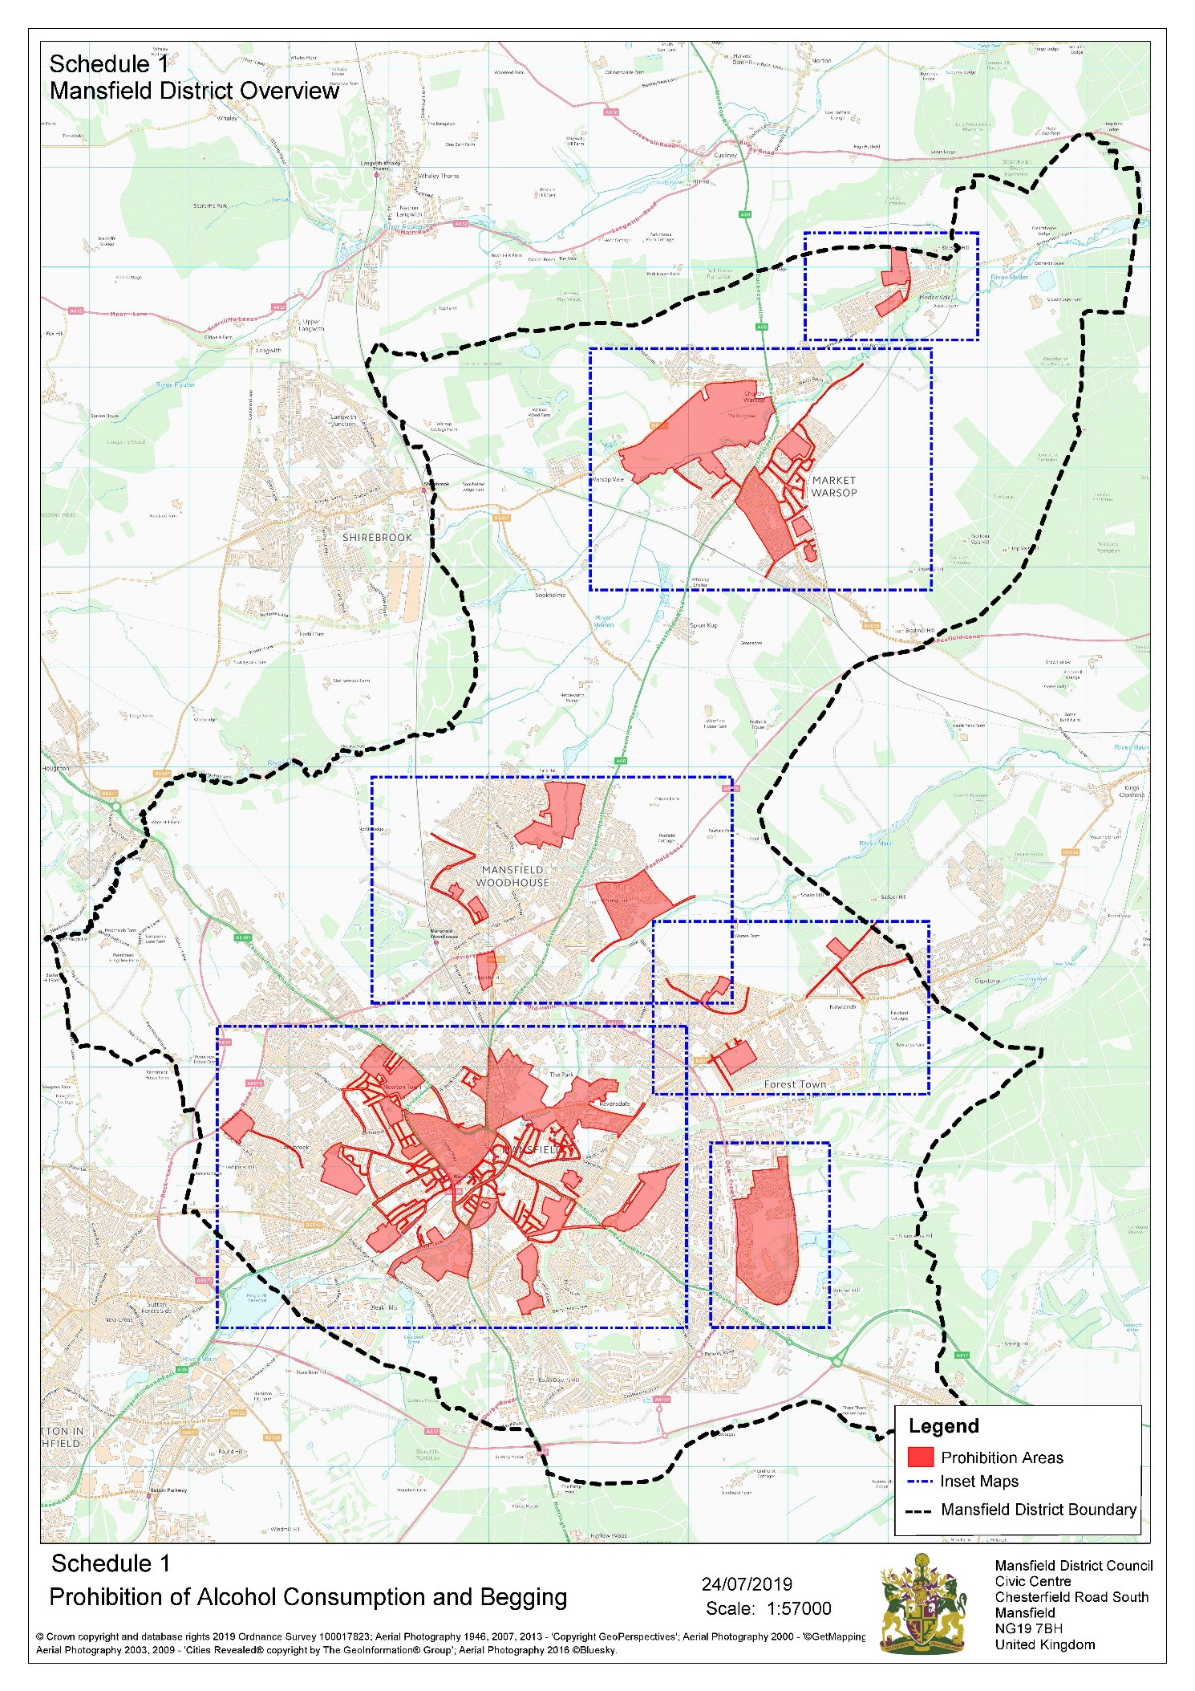

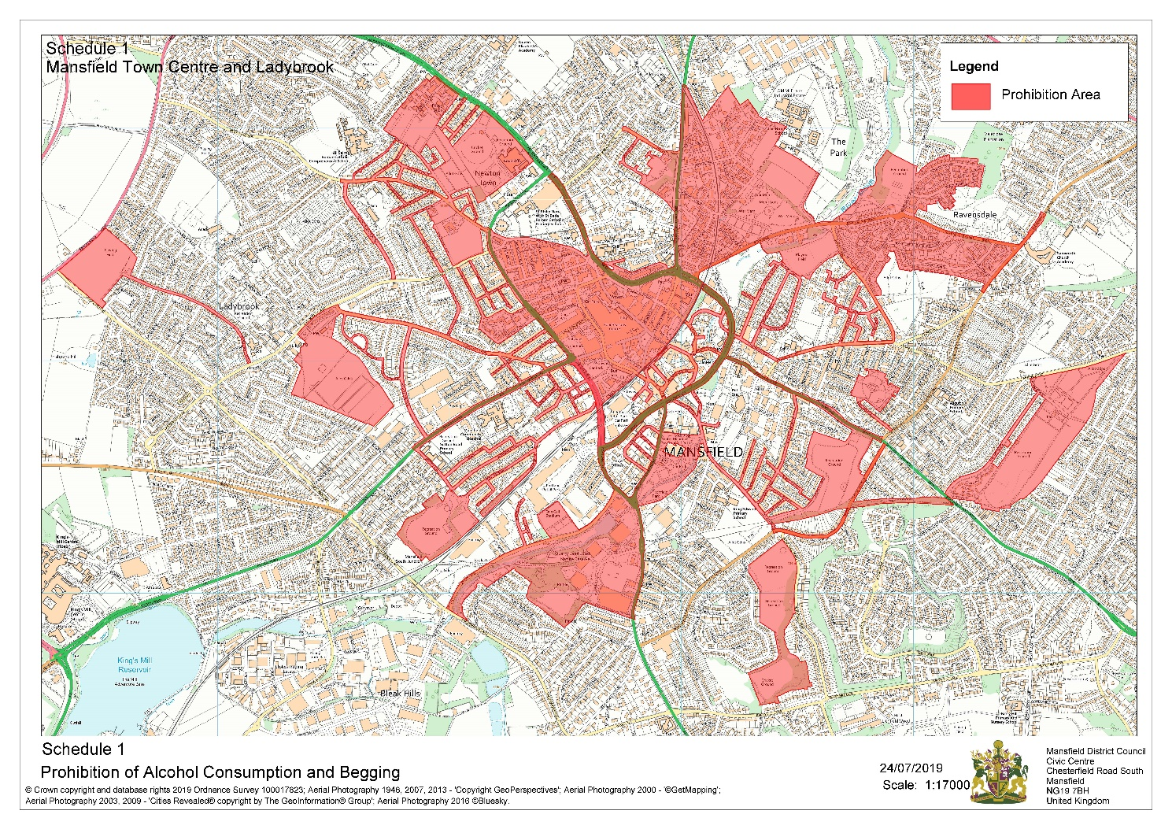

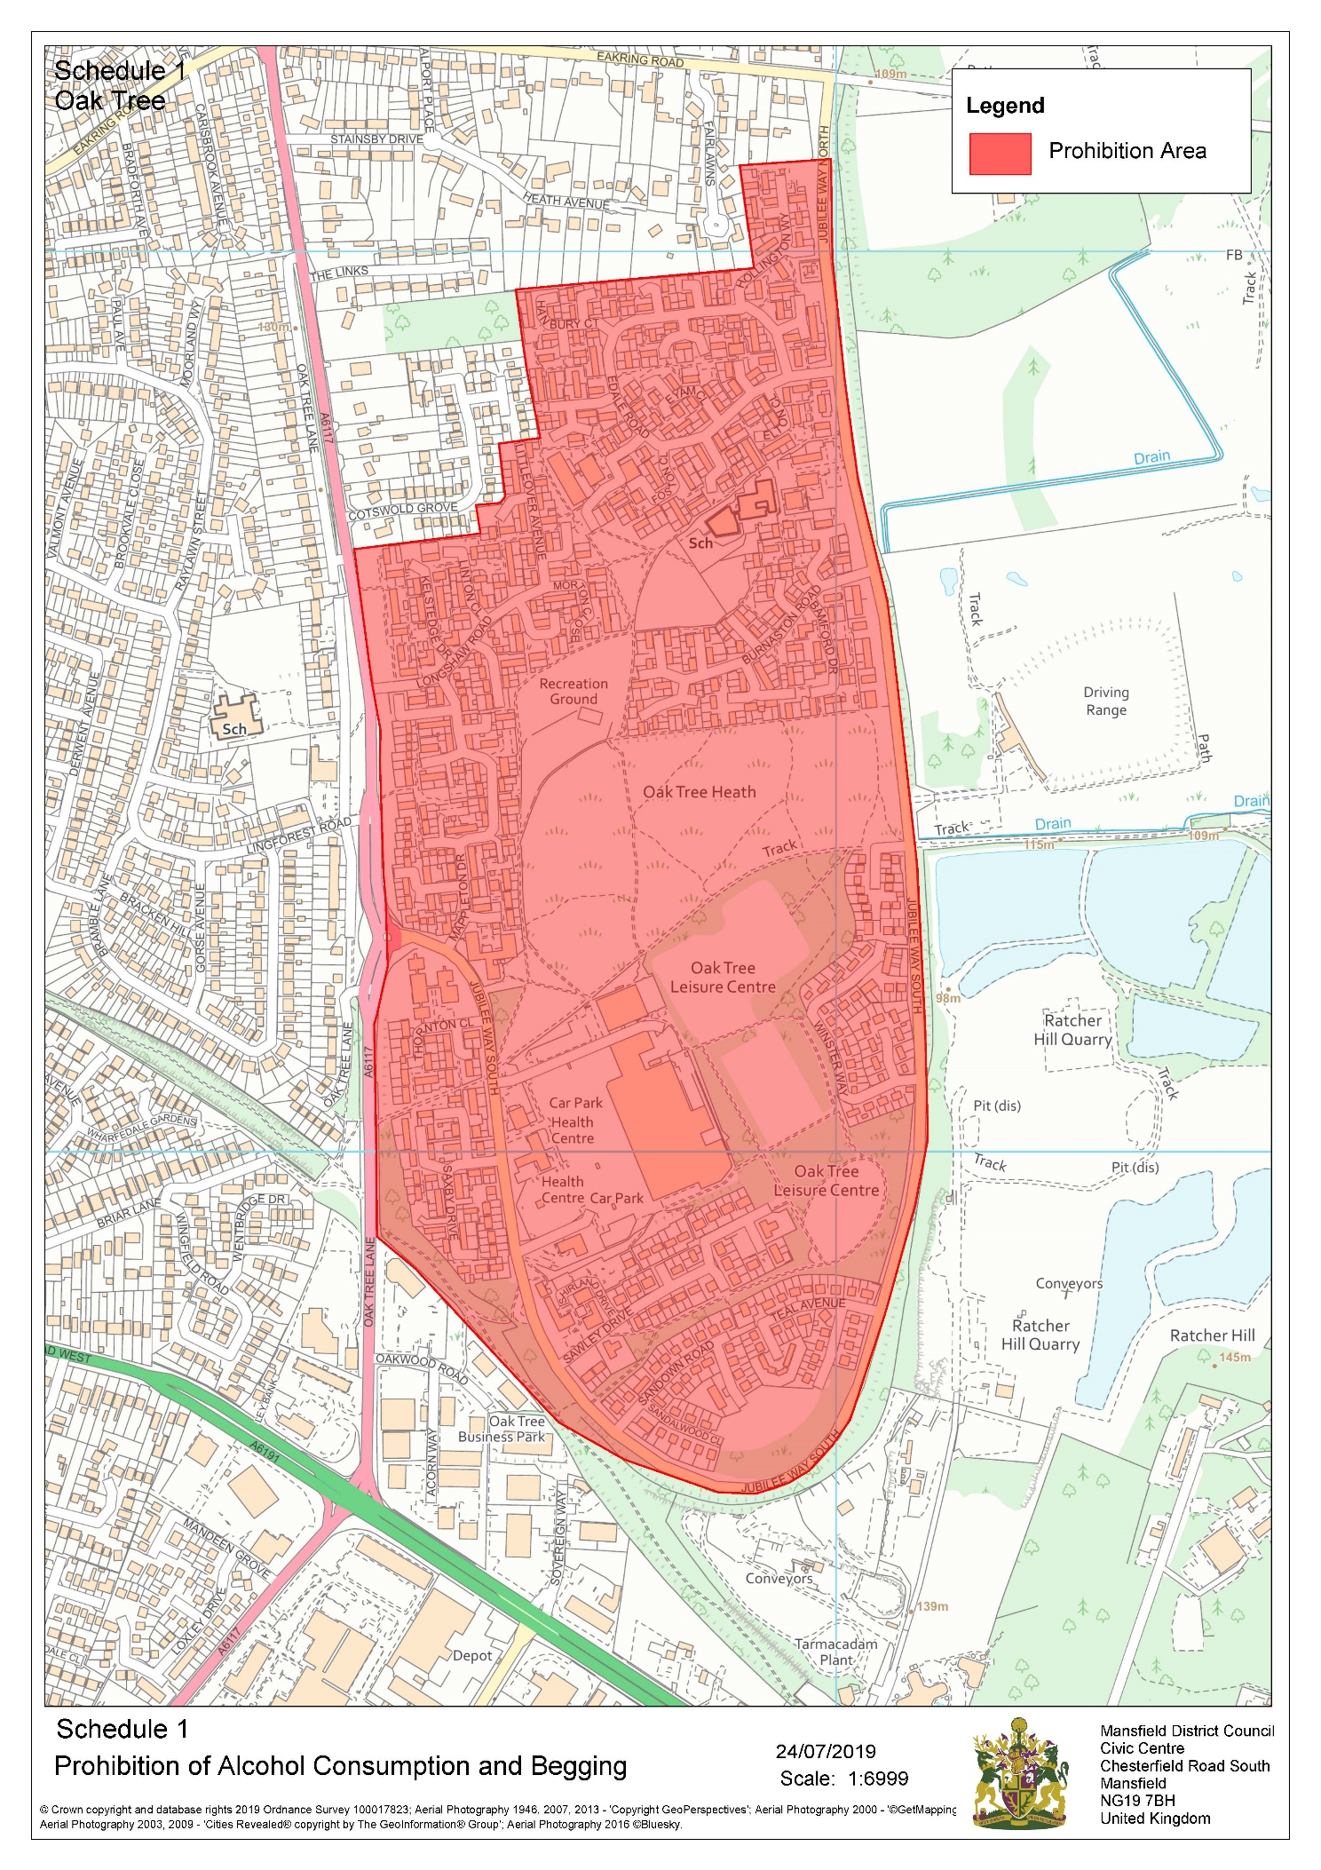

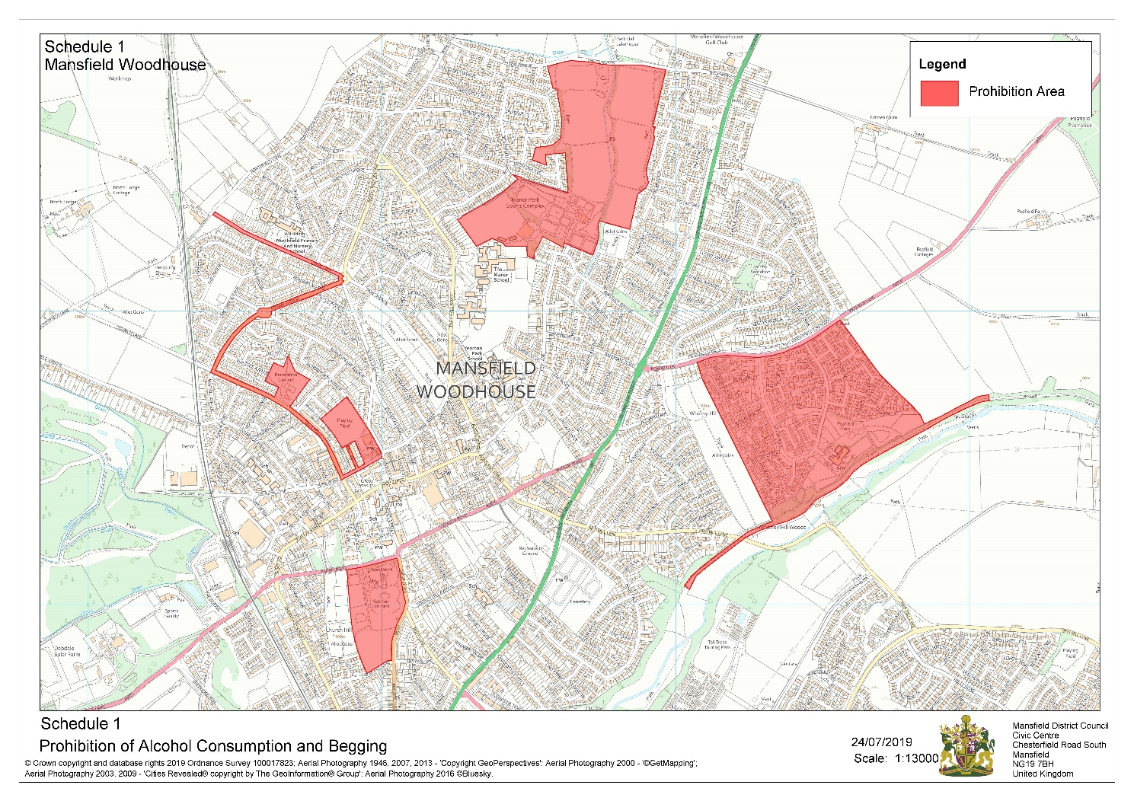

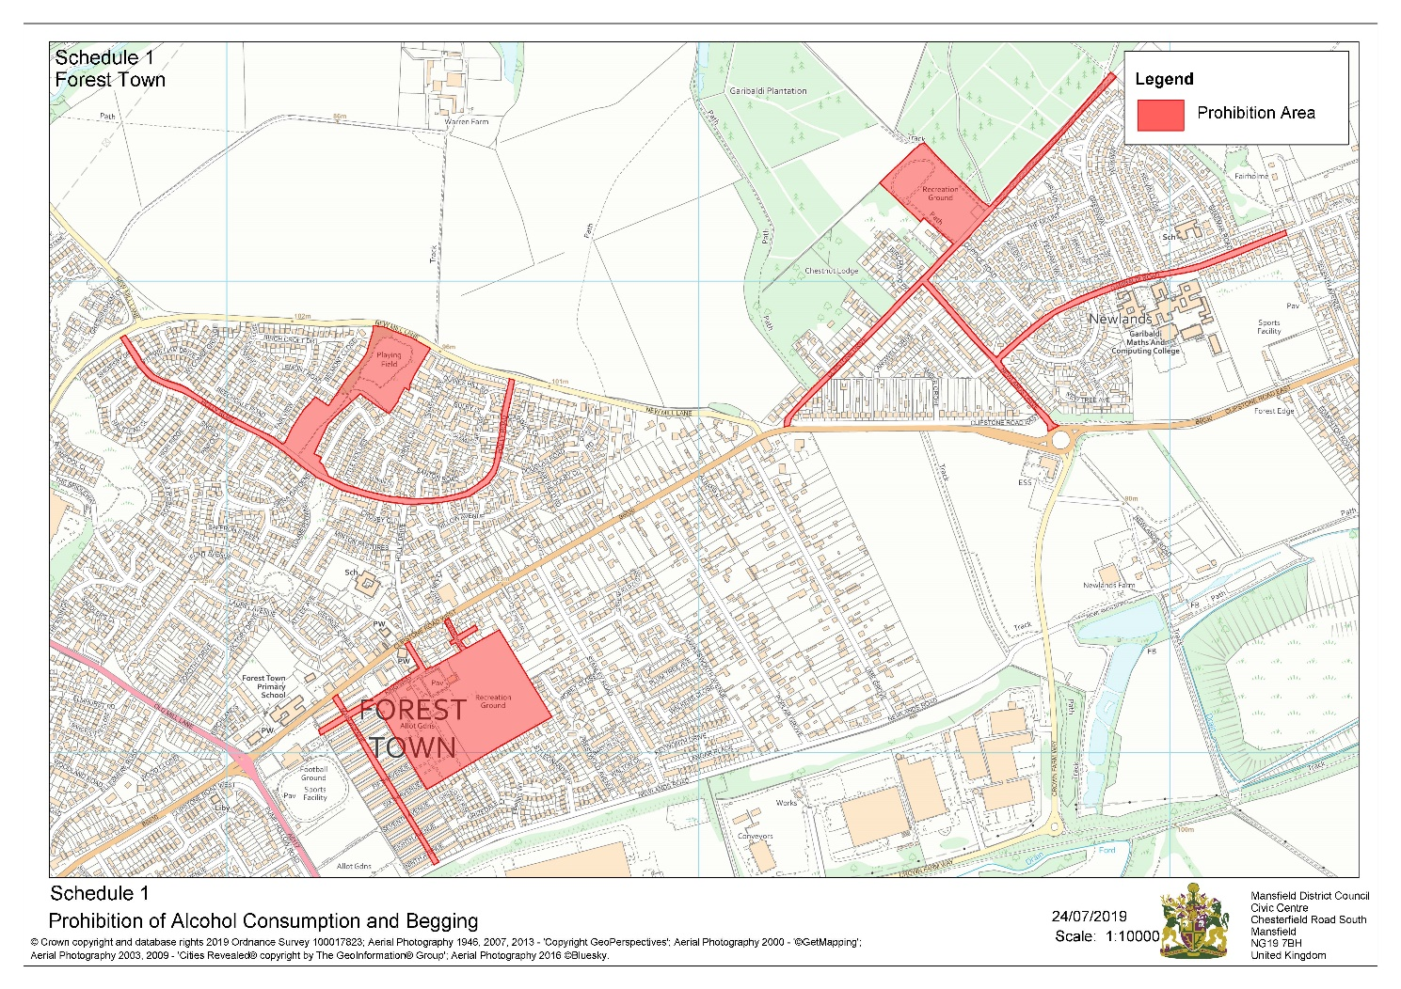

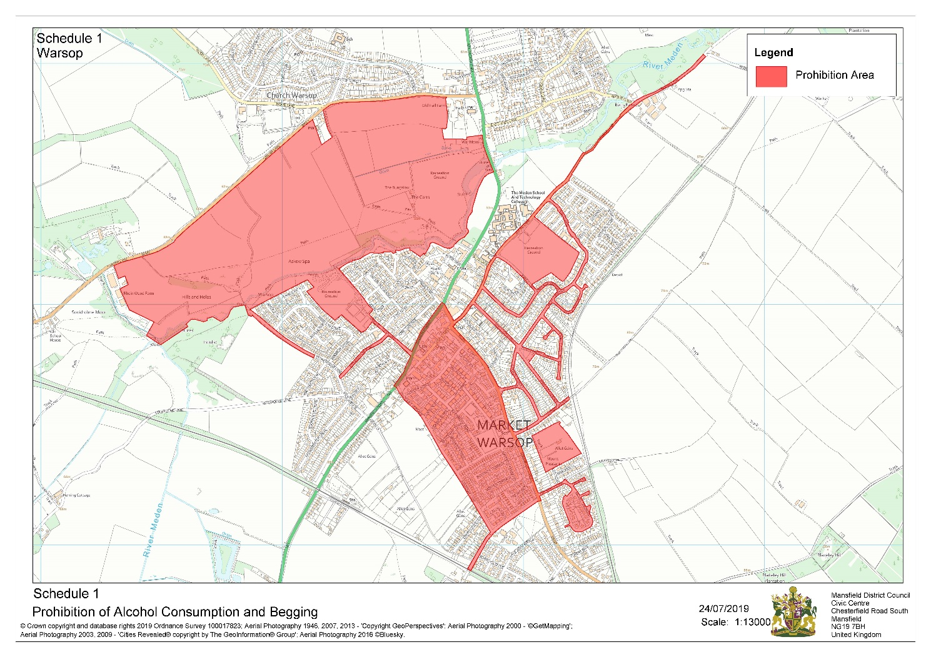

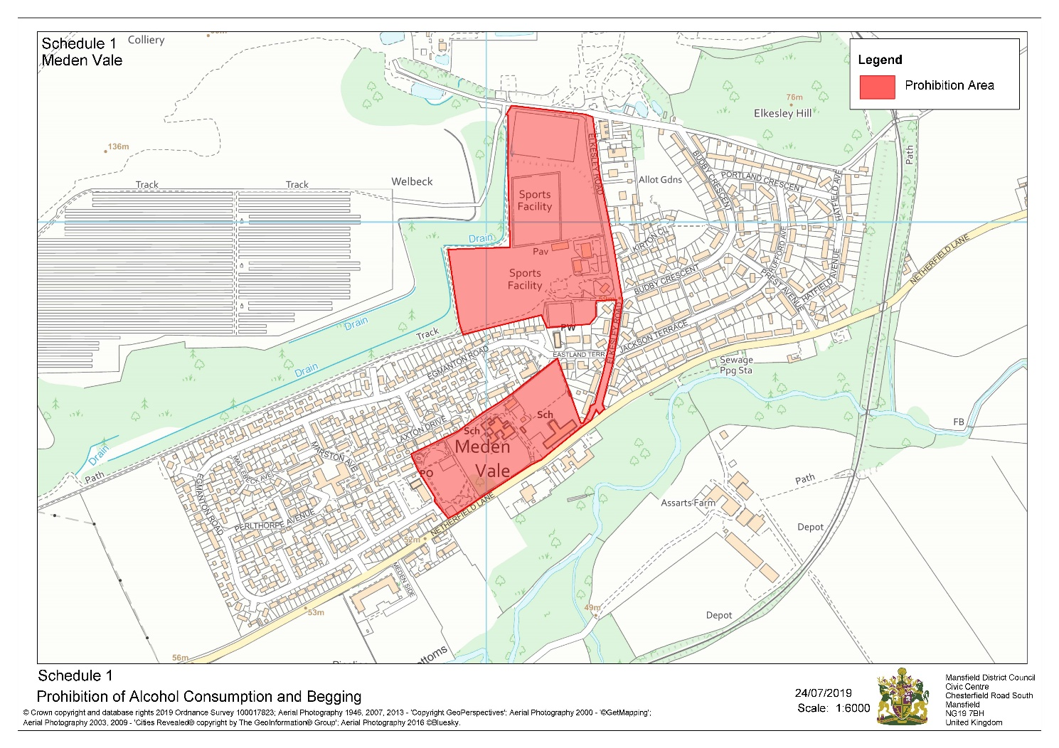

The Mansfield District Council Public Spaces Protection Order 2022
Schedule 2 (Urinating, Dog Fouling, Dogs on Lead by Direction - Prohibitions 3, 4 and 6)

Public spaces within the area shown coloured in red and edged in a black broken line on the plan attached, being Public Places in the Authority's area to which the Act applies.

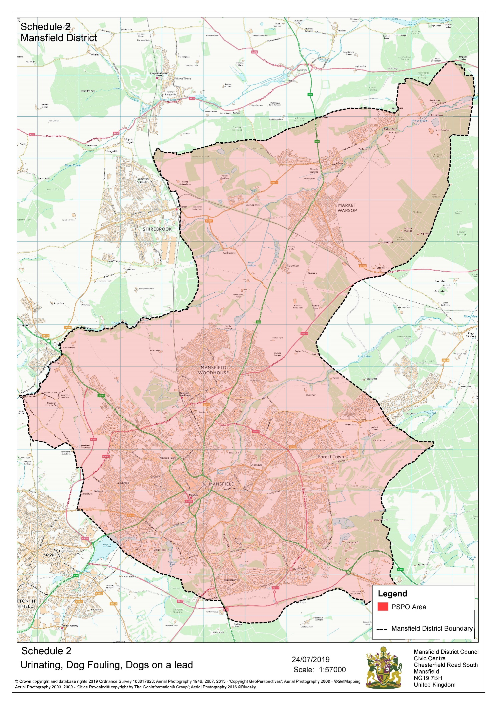
The Mansfield District Council Public Spaces Protection Order 2022
Schedule 3 (Dog Exclusion, – Prohibition 5)
Public spaces described in the following Schedule and shown within the areas coloured in blue on the plans attached, being Public Places in the Authority's area to which the Act applies
Land Designated Specifically:
1. Mansfield Town Centre
1.1 Park off Chesterfield Road South
1.2 Park Off Haddon Road
1.3 Carr Bank Park
1.4 Ladybrook Park
1.5 Ladybrook Place
1.6 Seaforth Square
1.7 The Knoll Play Area
1.8 Moor Lane Park
1.9 Titchfield Park
1.10 Park off Forest Road
1.11 Mansfield Cemetery

2. East Mansfield
2.1 Jackson Field
2.2 Fisher Lane Park
2.3 Racecourse Park
2.4 Kings Walk Open Space
2.5 Park Off Rydale Avenue
2.6 Ling Forest Play Area
2.7 Oak Tree Play Area
2.8 Sawley Drive Play Area
2.9 Berry Hill Park
2.10 King George V Playing Field
2.11 Epperstone Court Play Area

3. Forest Town
3.1 Queensway Park
4. Pleasley and Bull Farm
4.1 Pleasley Hill Cemetery
4.2 Woburn Road Play Area
4.3 Bull Farm Park
4.4 Park off Burlington Drive

5. Mansfield Woodhouse

5.1 The Green
5.2 Manor Park
5.3 Hornby Plantation Play Area
5.4 Yeoman Hill Park
5.5 Mansfield Woodhouse Welbeck Road Cemetery
5.6 Mansfield Woodhouse Cemetery
5.7 Peafield Park

6. Warsop

6.1 Wood Lane Play Area
6.2 Carr Lane Park
6.3 The Carrs
6.4 Cuckney Hill Cemetery
6.5 Ossington Close Park

7. Rainworth
7.1 Rainworth Open Space

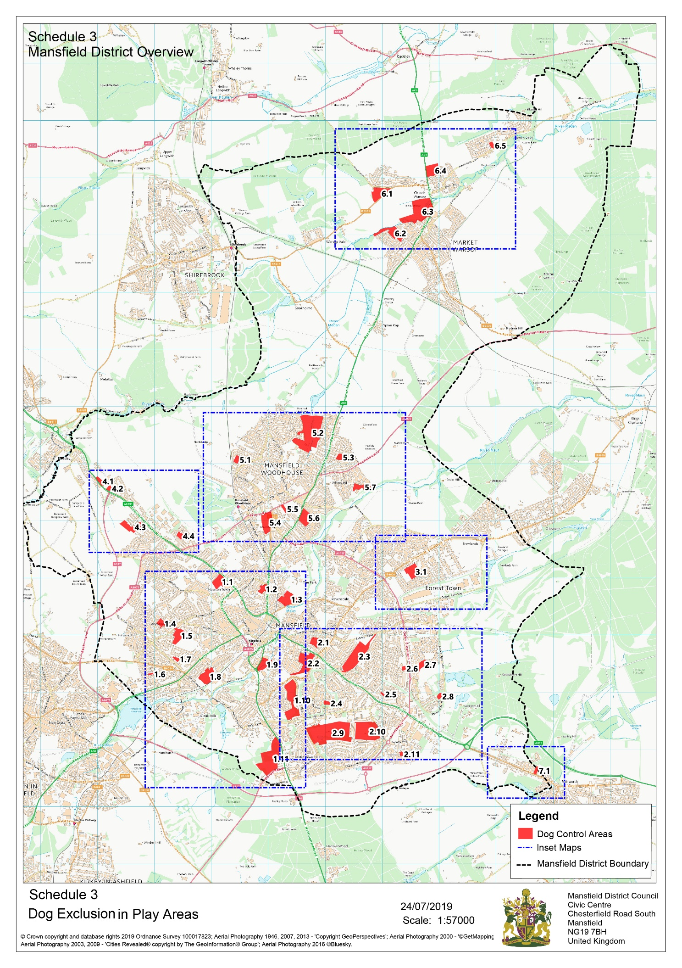
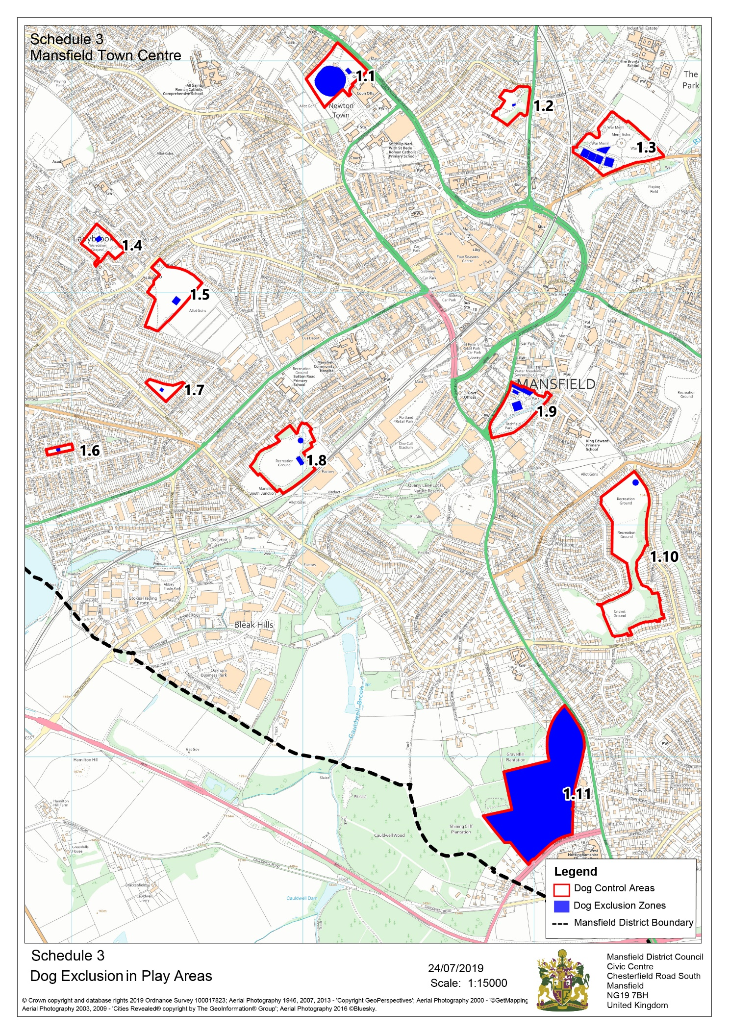
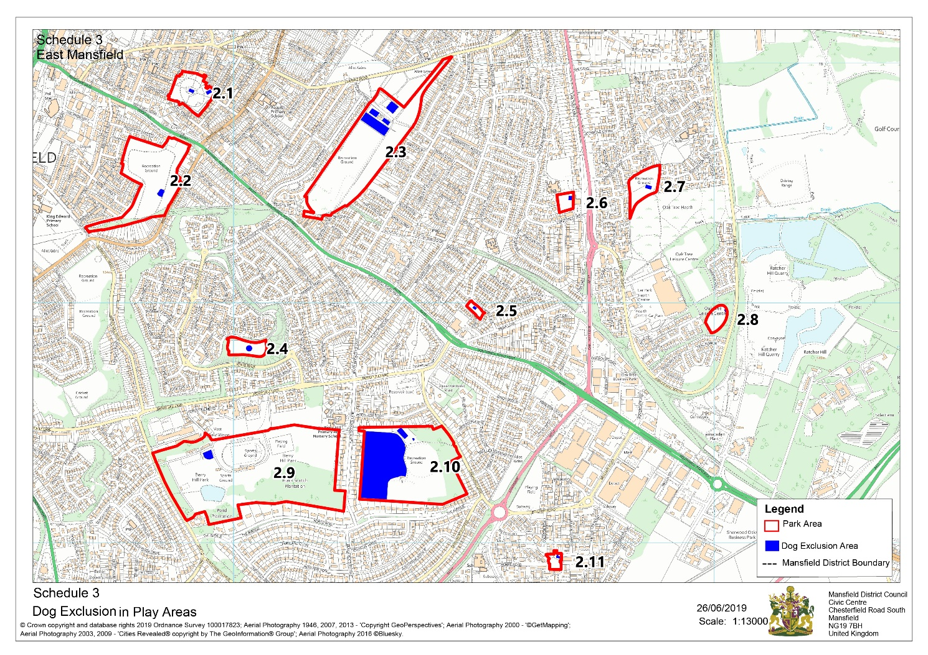

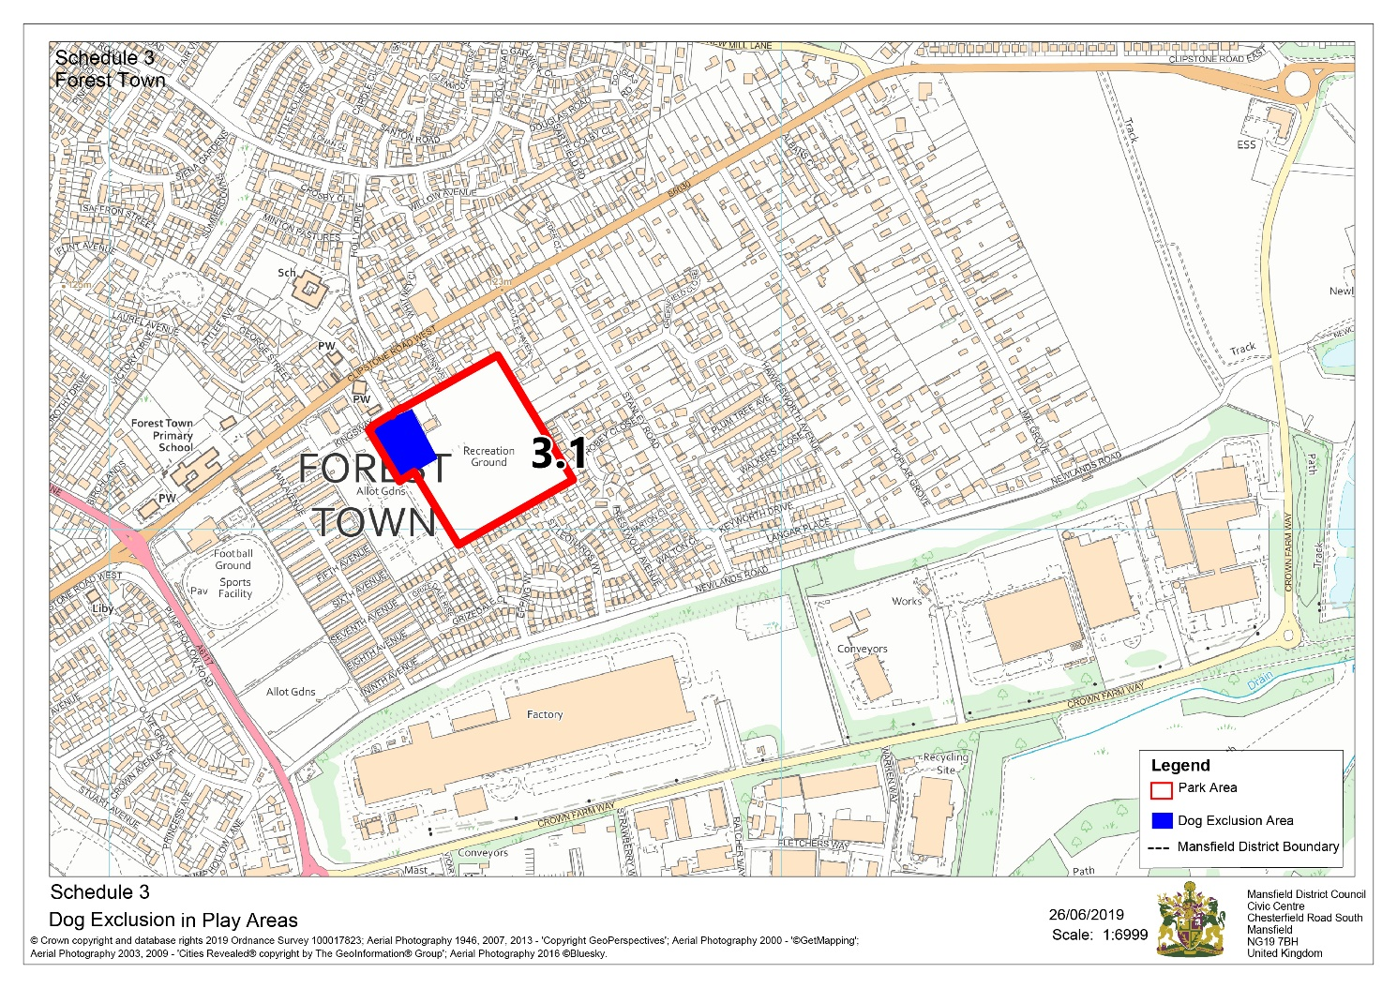

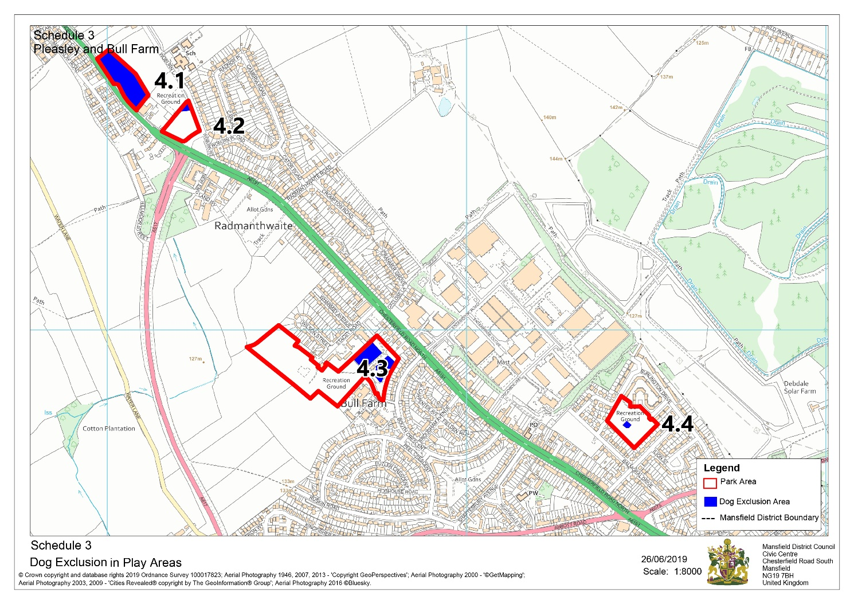

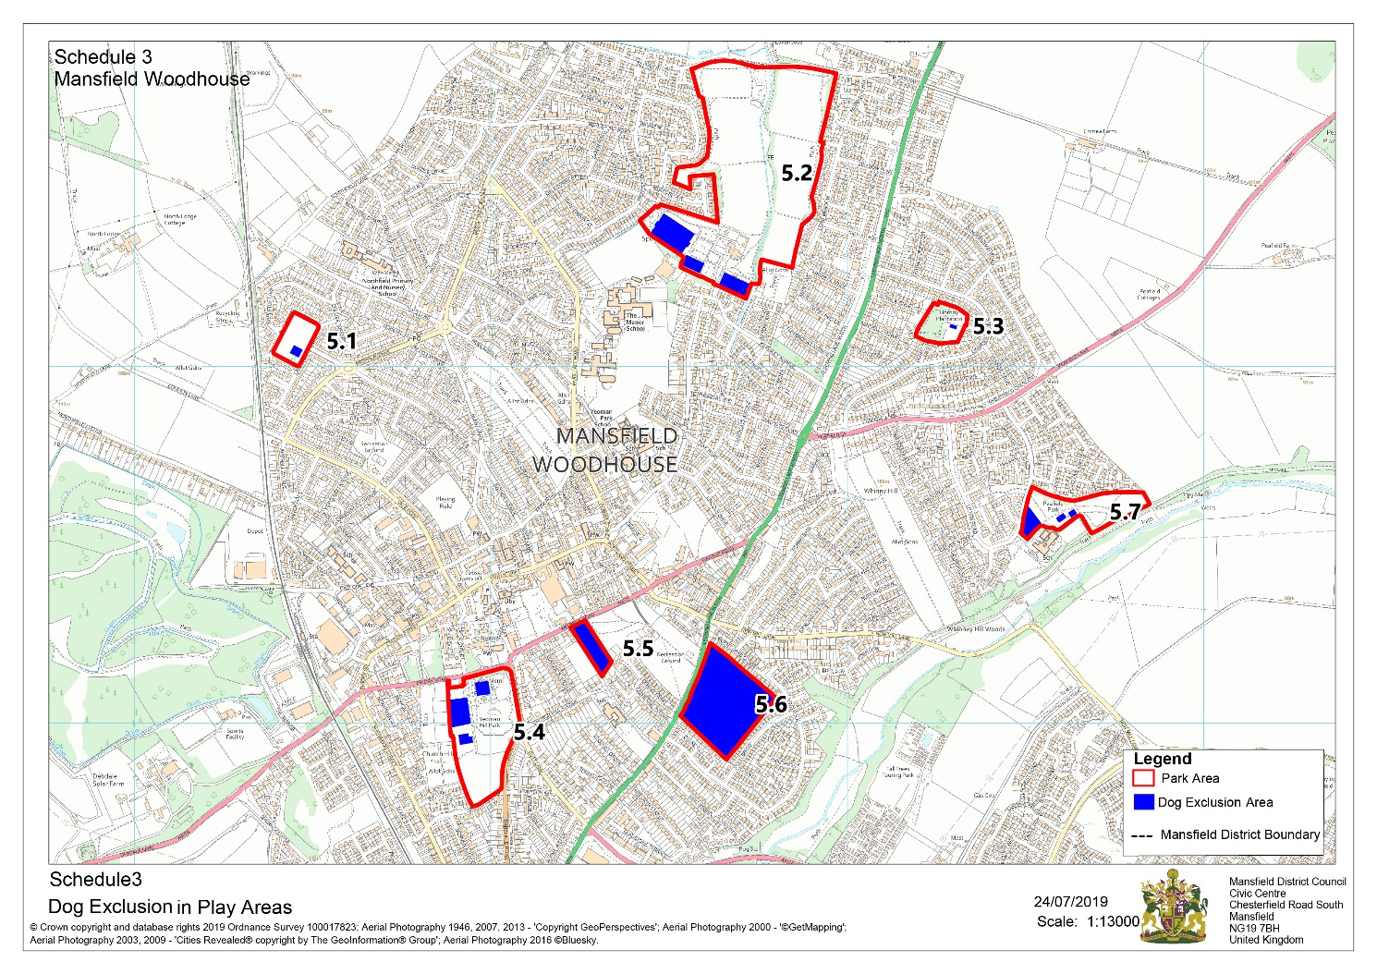

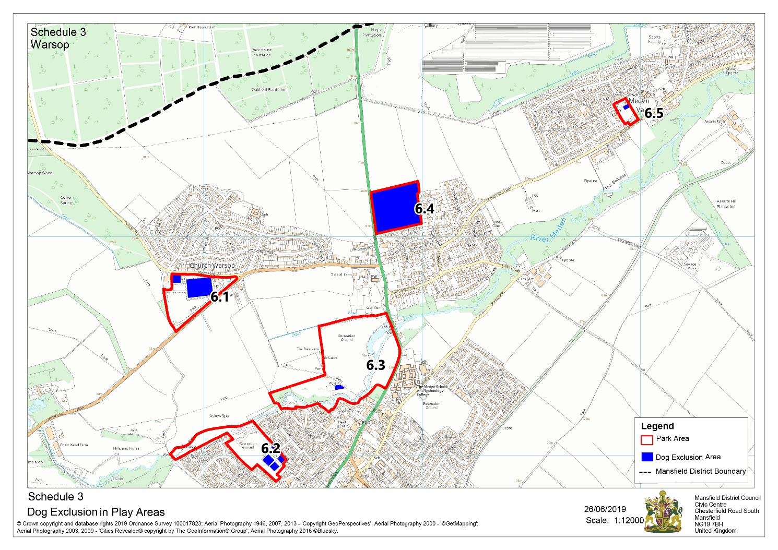

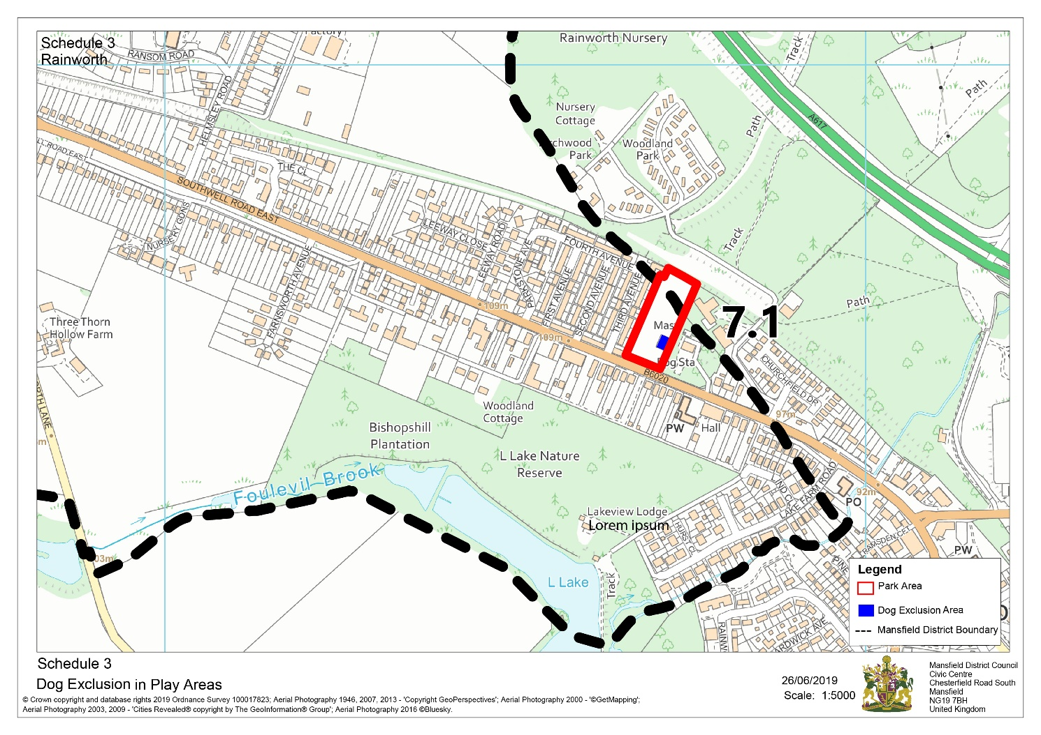

The Mansfield District Council Public Spaces Protection Order 2022
Schedule 4 (Direction to Move On – Prohibition 7)

Public spaces within the areas shown edged in red on the plans attached, being Public Places in the Authority's area to which the Act applies.

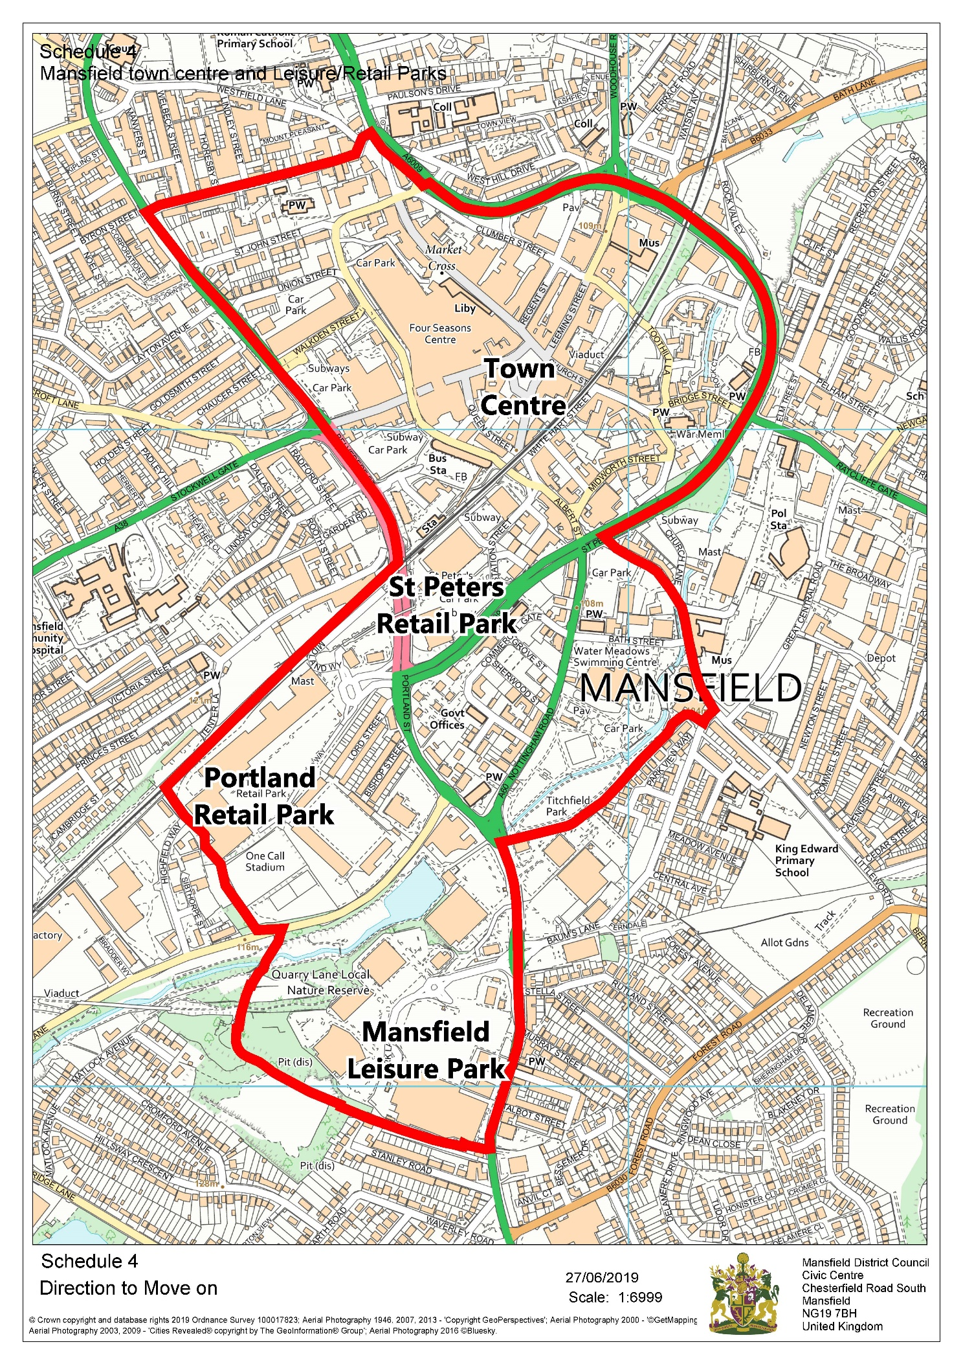
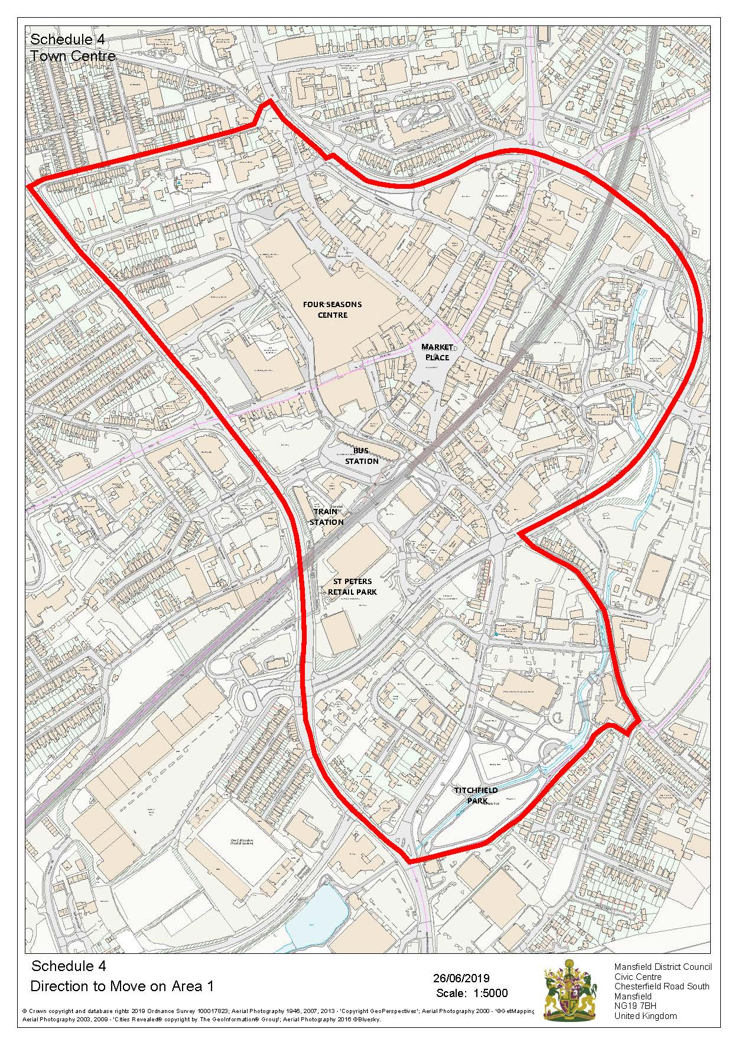
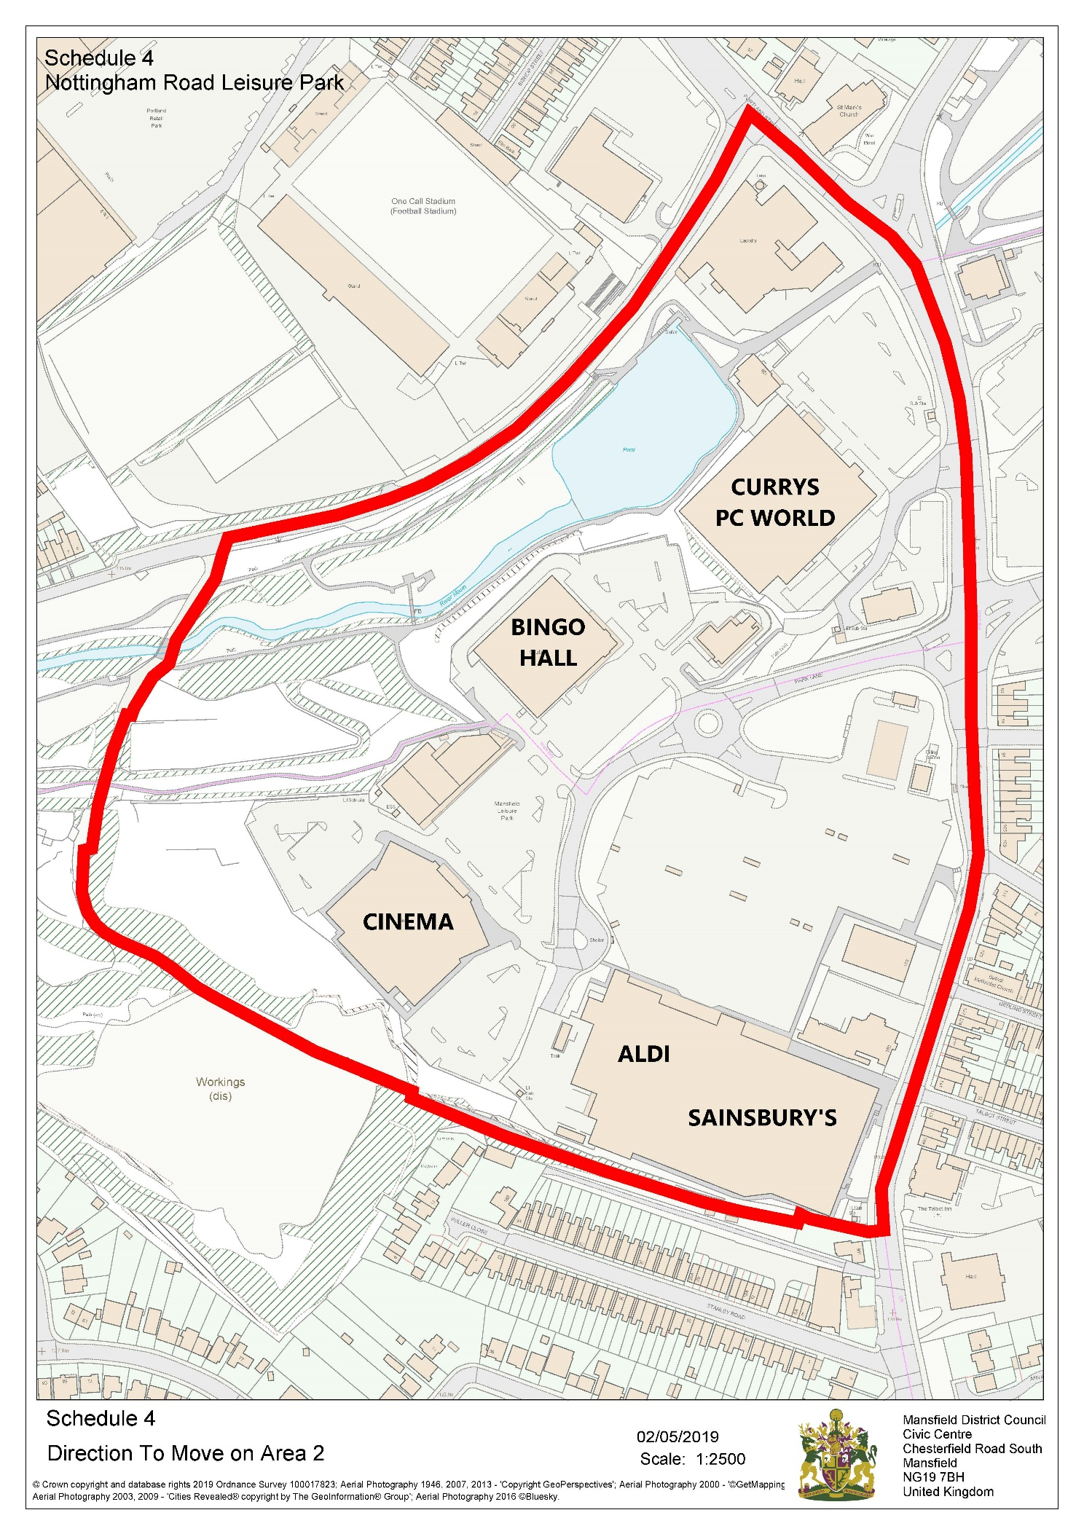
The Mansfield District Council Public Spaces Protection Order 2022
Schedule 5 (Restricting Access – Prohibition 8)
The highways described in the following Schedule and shown by bold red broken lines on the plans attached, being Public Places in the Authority's area to which the Act applies

Land Designated Specifically (“the Restricted Access Highways”):

Manor Estate, Mansfield Woodhouse:

Clerkson’s Alley, Mansfield

Alfred Court, Mansfield

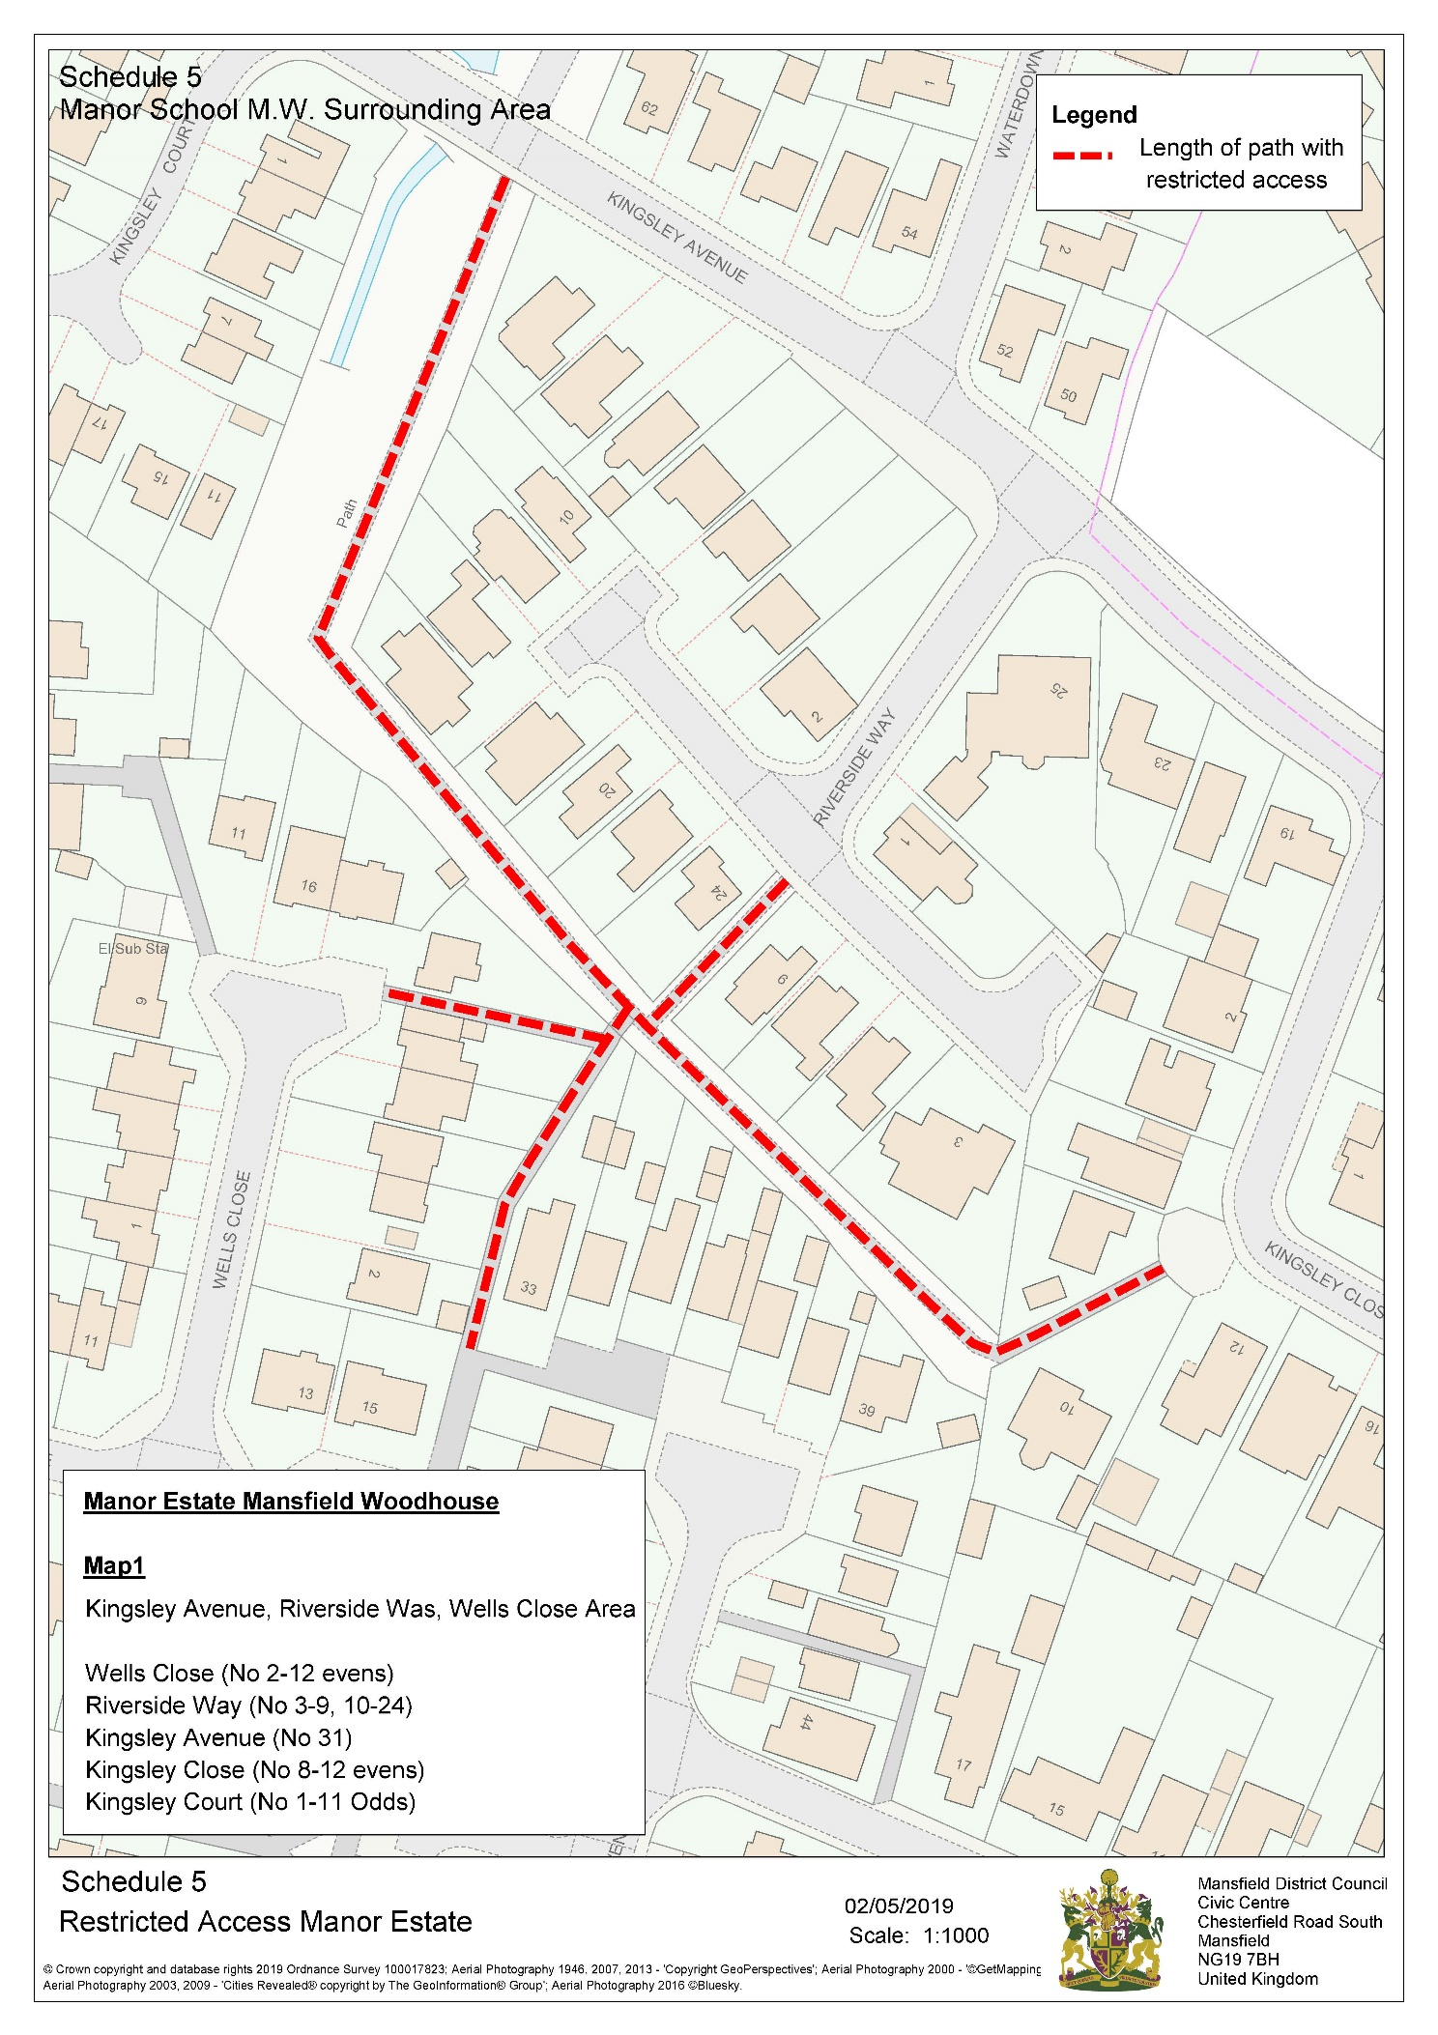

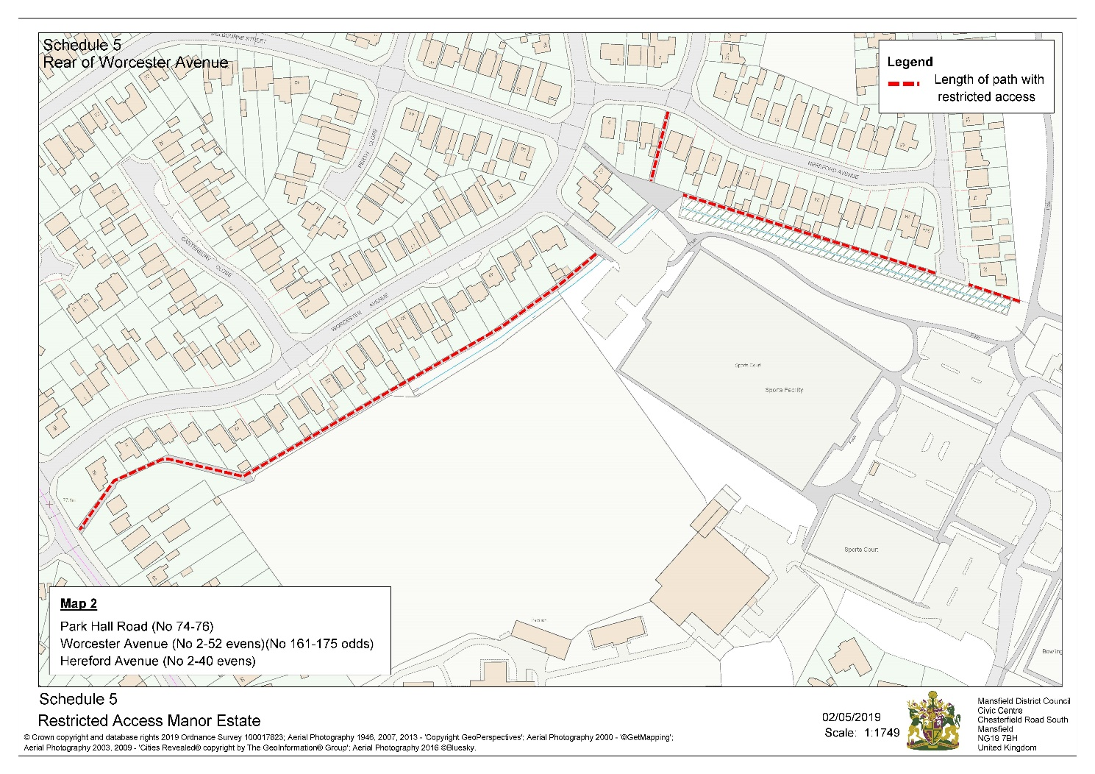

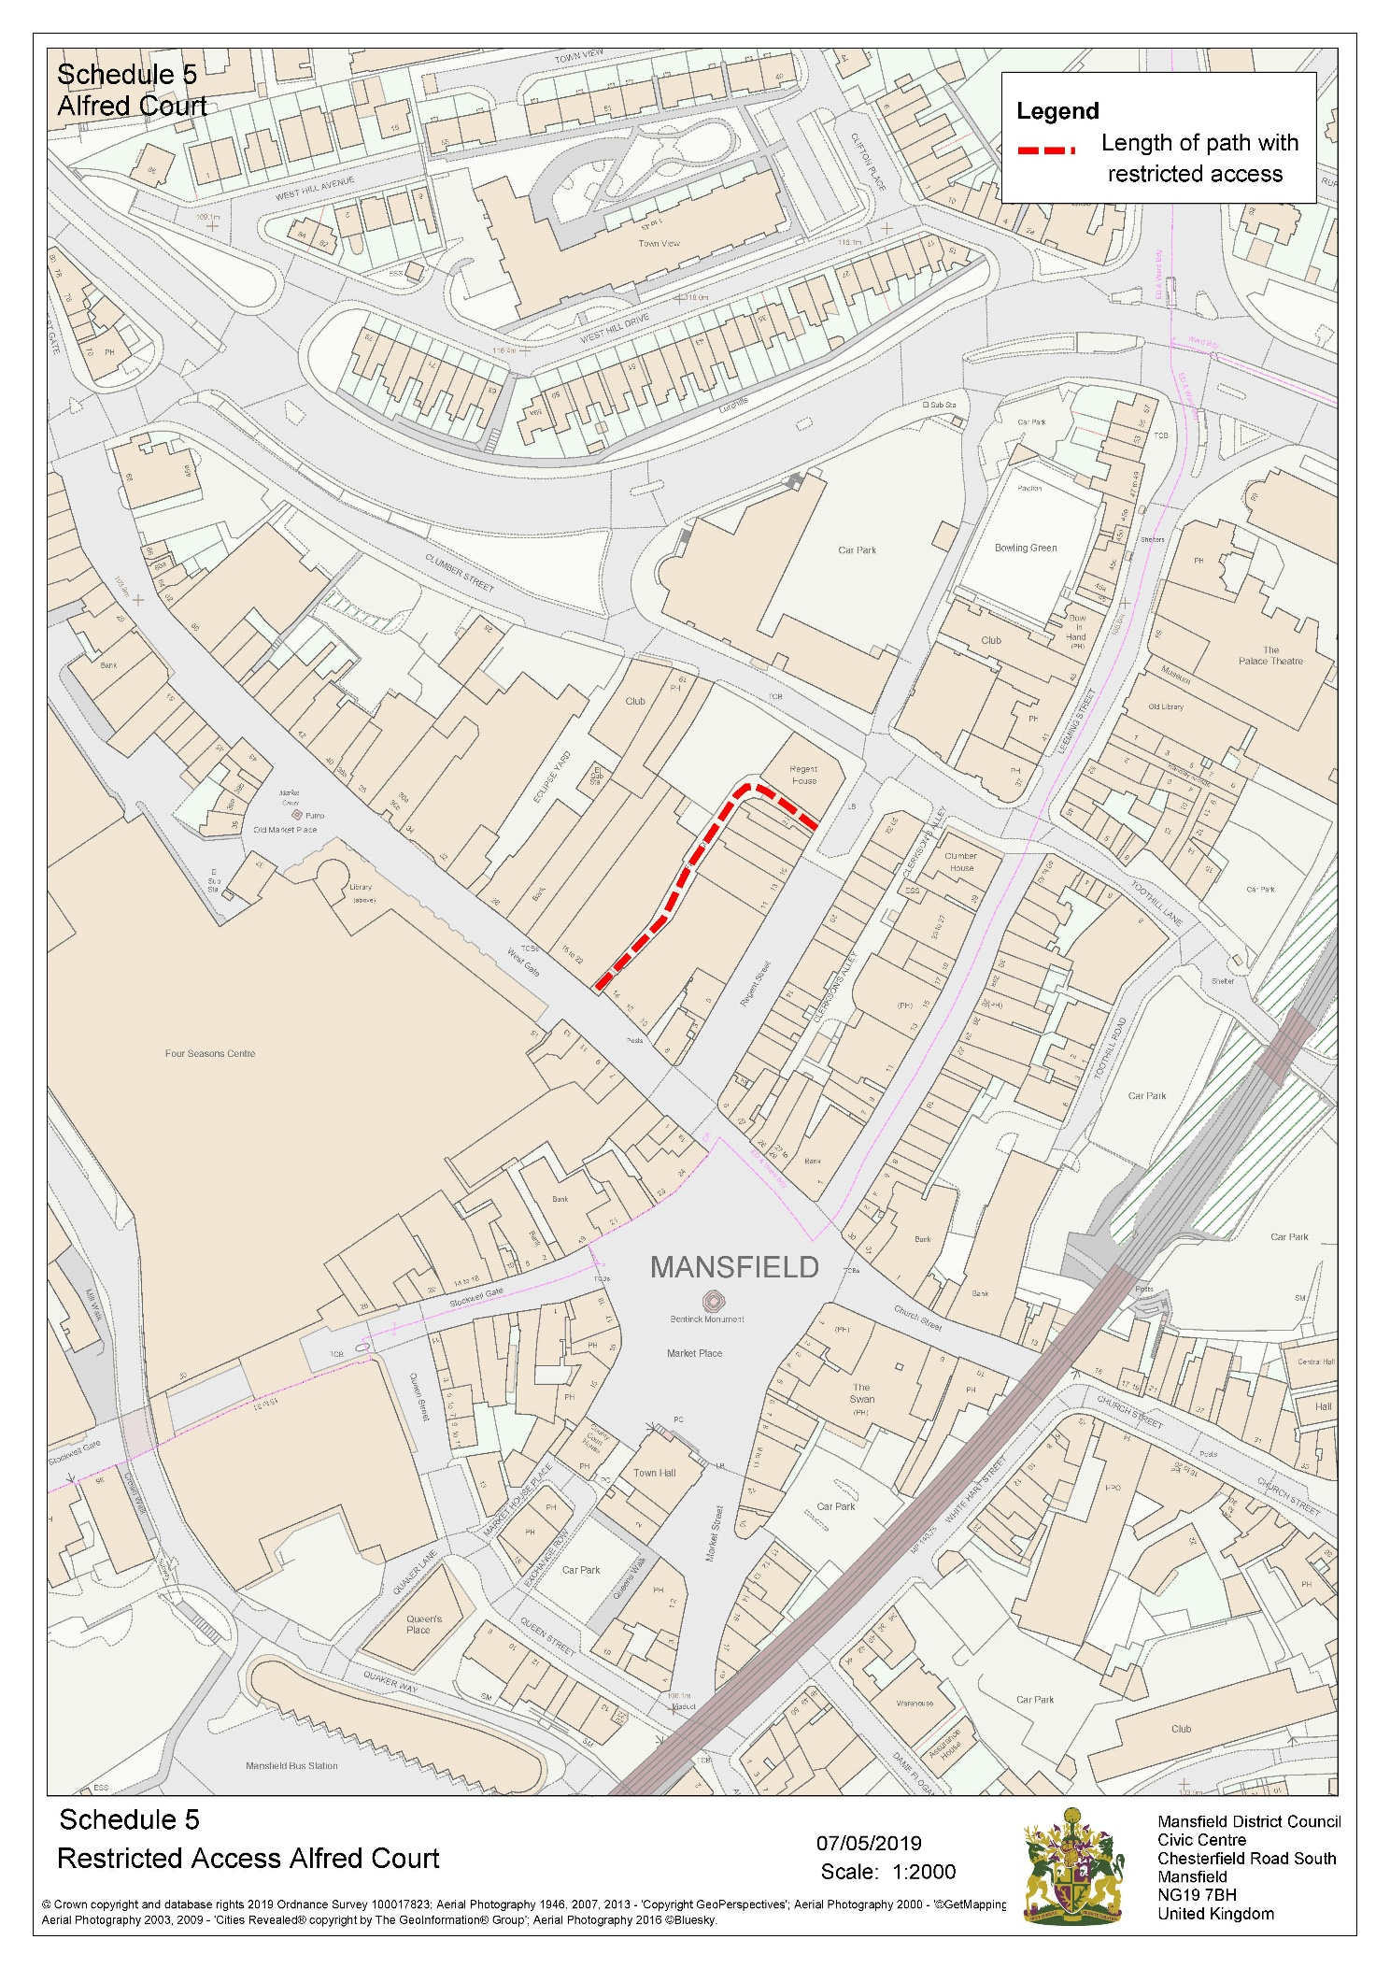
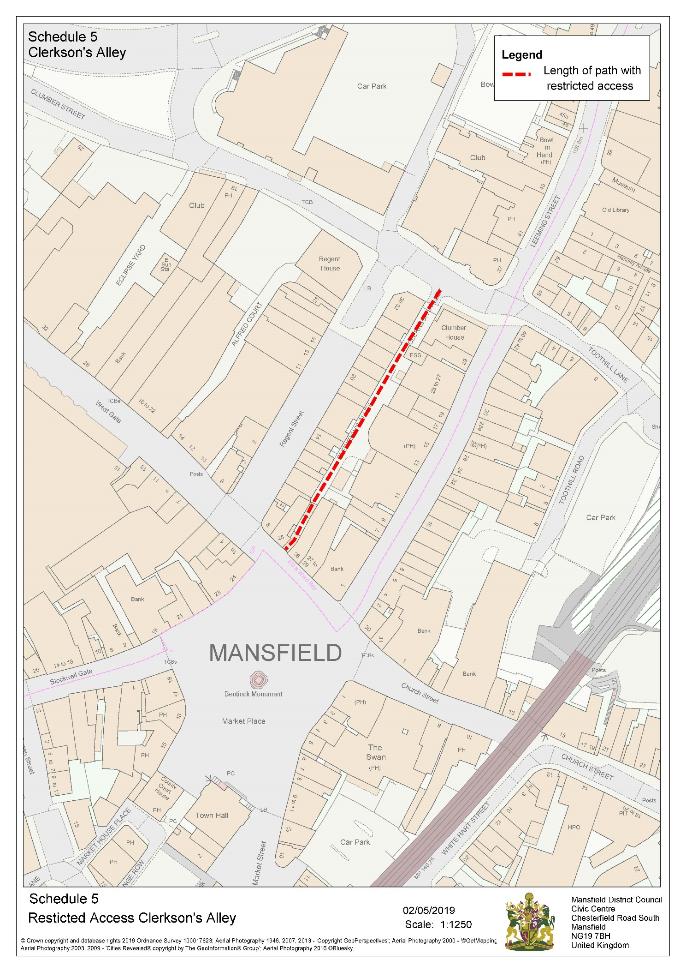
The Mansfield District Council Public Spaces Protection Order 2022
Schedule 6 (Cycling - Prohibition 9)
Public spaces described in the following Schedule being Public Places in the Authority's area to which the Act applies:
The pedestrian market area of Mansfield as detailed below together with the areas edged and hatched in red on the plan attached:
• Stockwell Gate
• Westgate
• Regent Street
• Leeming Street
• Church Street
• Market Place

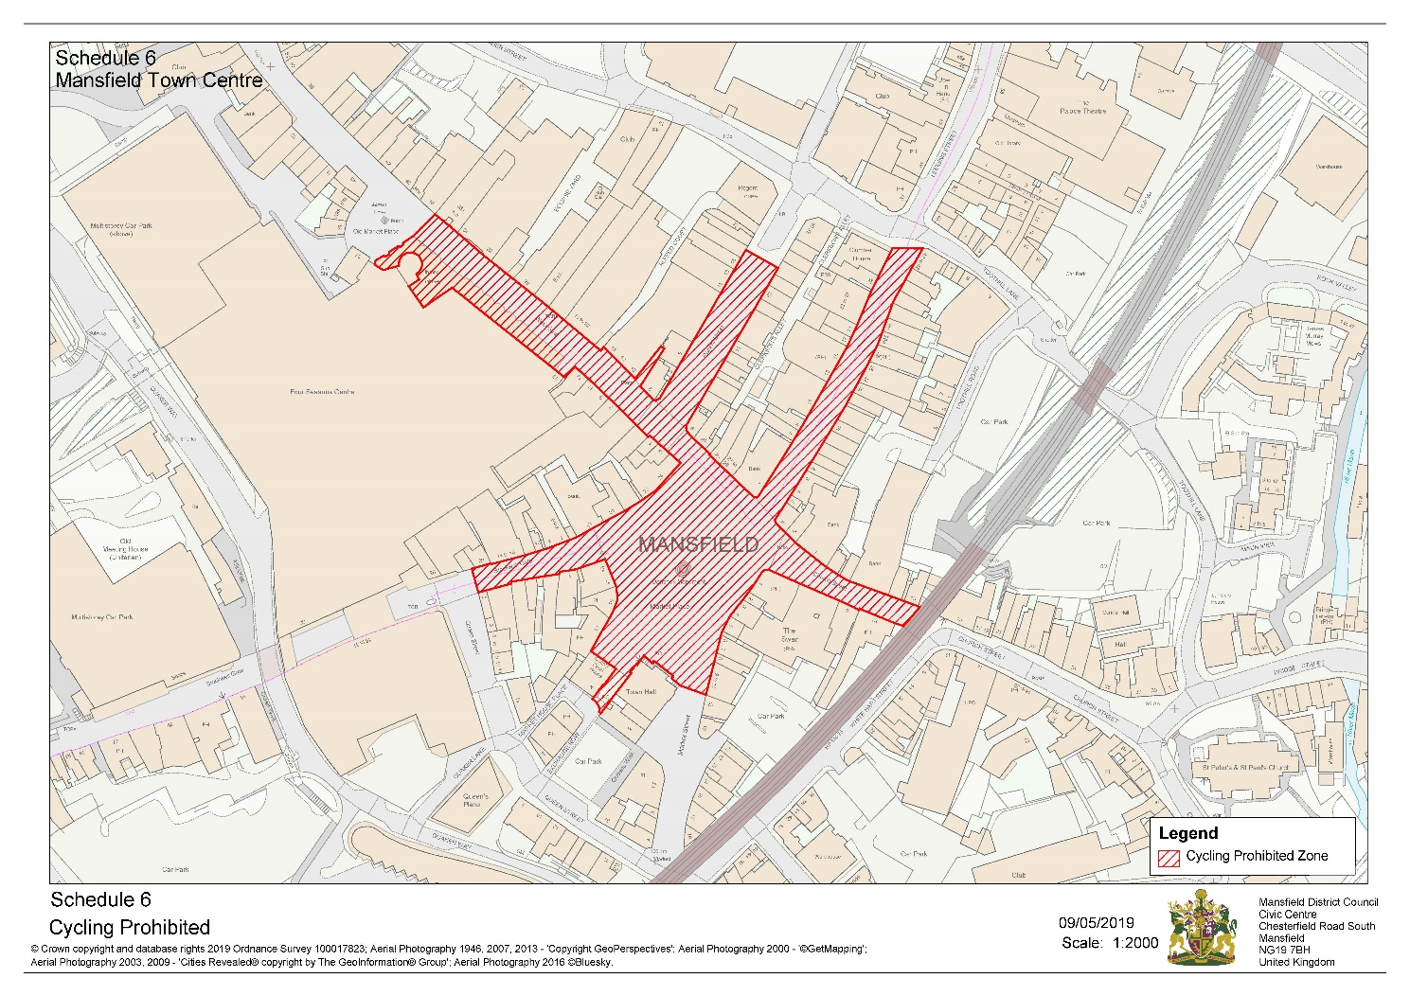

The Mansfield District Council Public Spaces Protection Order 2022
Schedule 7 (Prohibition of Driving Mechanically Propelled Vehicles
- Prohibition 10)
Public spaces described in the following Schedule being Public Places in the Authority's area to which the Act applies:
